The user can enter a birthday message and select various message options. The webpage uses CSS to align the form widgets vertically. The webpage should look like the following:

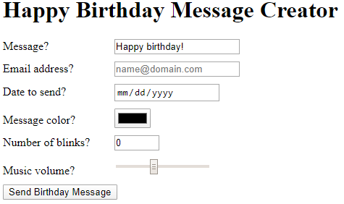

The form should:

* Use the regular expression [a-zA-Z0-9-_\.]+@[a-zA-Z0-9-]+(?:\.[a-zA-Z0-9-]+)* for the email address <input> to verify the user enters what looks to be an email address
* Use a date <input> for specifying a date to send the message
* Use a color <input> for selecting the message color
* Use a number <input> with a default value of 0, minimum of 0, and maximum of 10 for number of times the message blinks
* Use a range <input> with a default value of 20, minimum of 0, and maximum of 50 for the music volume
* Use a submit <button> that reads "Send Birthday Message"
* Specify an id attribute for all form elements that matches the given for attribute of each associated <label>
* Specify a name attribute for all form elements that matches each element's id attribute